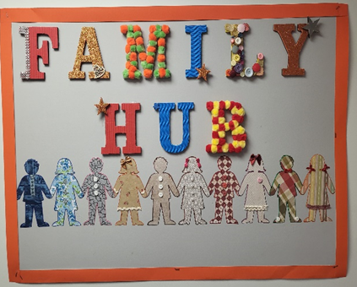

**FAMILY HUB**

* Promote family activities happening in the local community.
* Arrange workshops from speakers or professionals from outside agencies.
* Organise regular, flexible, informal discussion groups.
* Invite parents with specific knowledge, experiences or unique skills to run parent learning sessions.
* Arrange befriending sessions between families who have experienced similar circumstances.
* Signpost to correct agencies.
* Use Class Dojo to share information & maintain good communication.
* Ask for your views and ideas with regular questionnaire’s.
* Support families during TAC meetings and other appointments.
* Moving forward begin our Heaton’s Super Siblings support group!
* Use Heaton’s School’s on-site facilities to arrange fun Parent Wellbeing Sessions.
* Support maybe available in the following areas:
  + Benefits.
  + Form Filling.
  + Charity Applications.
  + Support Letters.
  + Housing.
  + Self-Care.
  + Behaviours.
  + Mental Health.
  + Friendships.
  + Family difficulties.
  + Transport.
  + Parenting Strategies.
  + Healthy Eating.
  + Training, courses or further education.
  + Volunteering.
  + Employment, CV writing.
  + Grief.
  + Attendance.
  + Food vouchers.