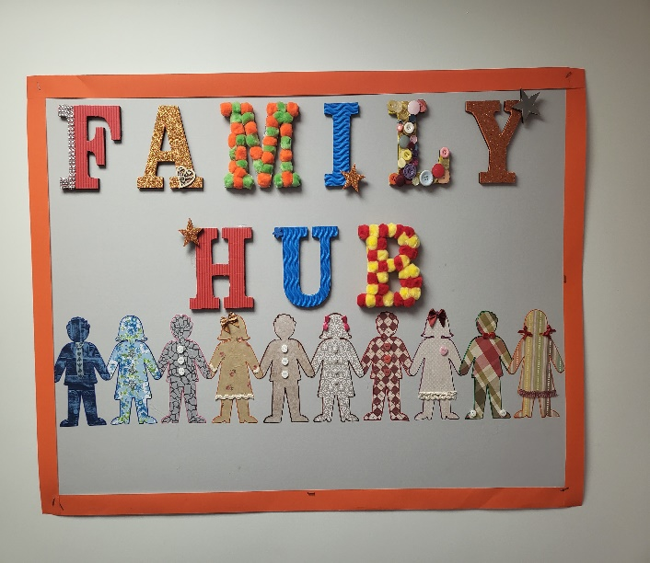

Hello & Welcome!

I’m Melanie, I prefer to be called Mel. I am the new Family Liaison Assistant at Heaton School.

Over the coming months, I will initiate the new Family Hub. A central point for our families to turn too when help, advice and friendship is needed. The hub is a calm, relaxing and safe space to enable you to feel at ease. A place for informal chats and to feel listened too.

I am here to support your family the best I can. Parenting isn’t an easy job and at times it can be challenging, we all need someone to talk too. I can’t promise to have all the answers but will aim to find a solution. Anything discussed will be in confidence, however I will refer to more experienced colleagues & agencies when needed to ensure your provided with the best & most appropriate advice to support your family.

When life is busy I can be flexible in meeting arrangements. If you can’t get to our family hub, I’ll bring the hub to you! I encourage you to talk to me either in person or a phone call but it’s ok if you prefer email & messaging via DOJO, whatever makes you feel comfortable.

My hours of work are 8:45am till 3:30pm. In the morning, I will be welcoming at our main entrance if you need a chat.

You can contact me:

* Via the school office 0161 432 1931
* Email. [Melanie.Sill@heaton.stockport.sch.uk](mailto:Melanie.Sill@heaton.stockport.sch.uk)
* Via class dojo.

My aim is to empower our parents, encourage parental involvement within school and support parental wellbeing, after all you need to look after yourselves too! Heaton School is a positive place and our family’s matter.

